DAY 10

CLASS EXERCISE 2

    @PostMapping("/api/customer")

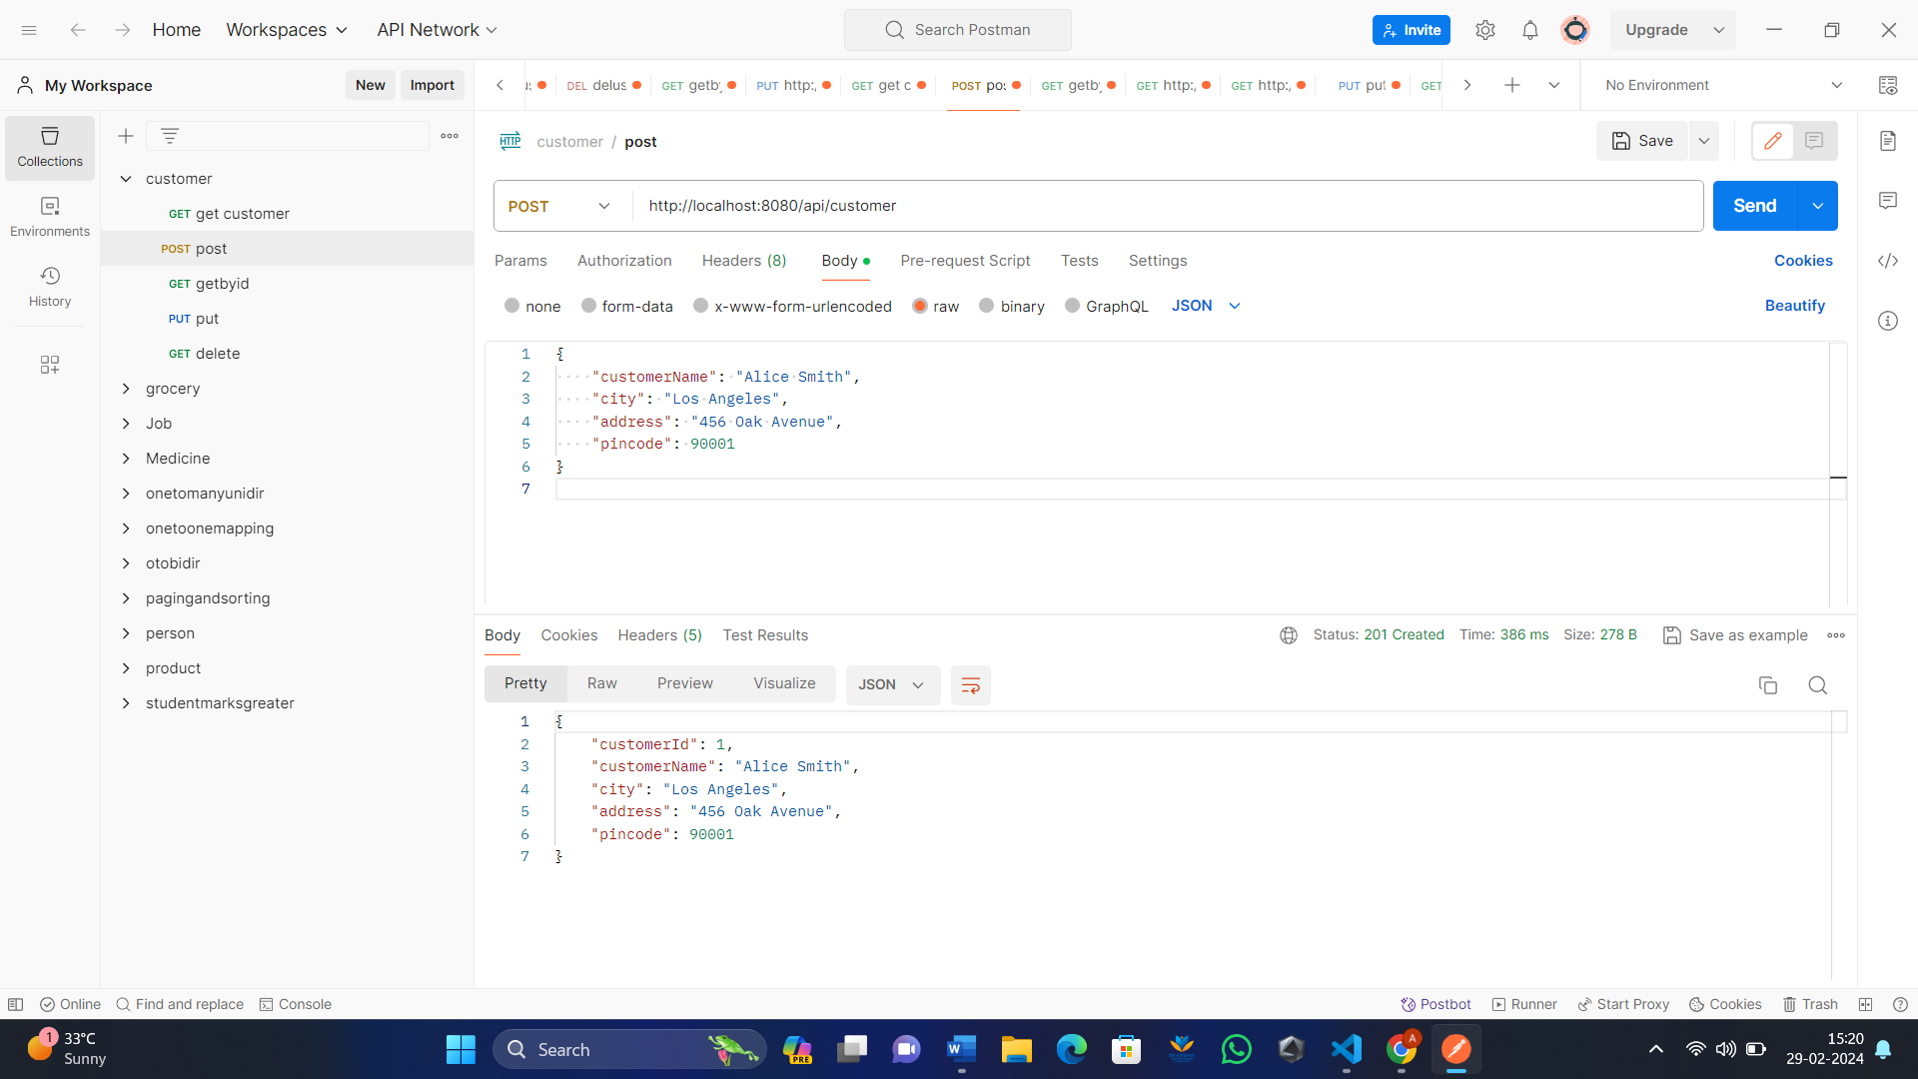

    @GetMapping("/api/customer")

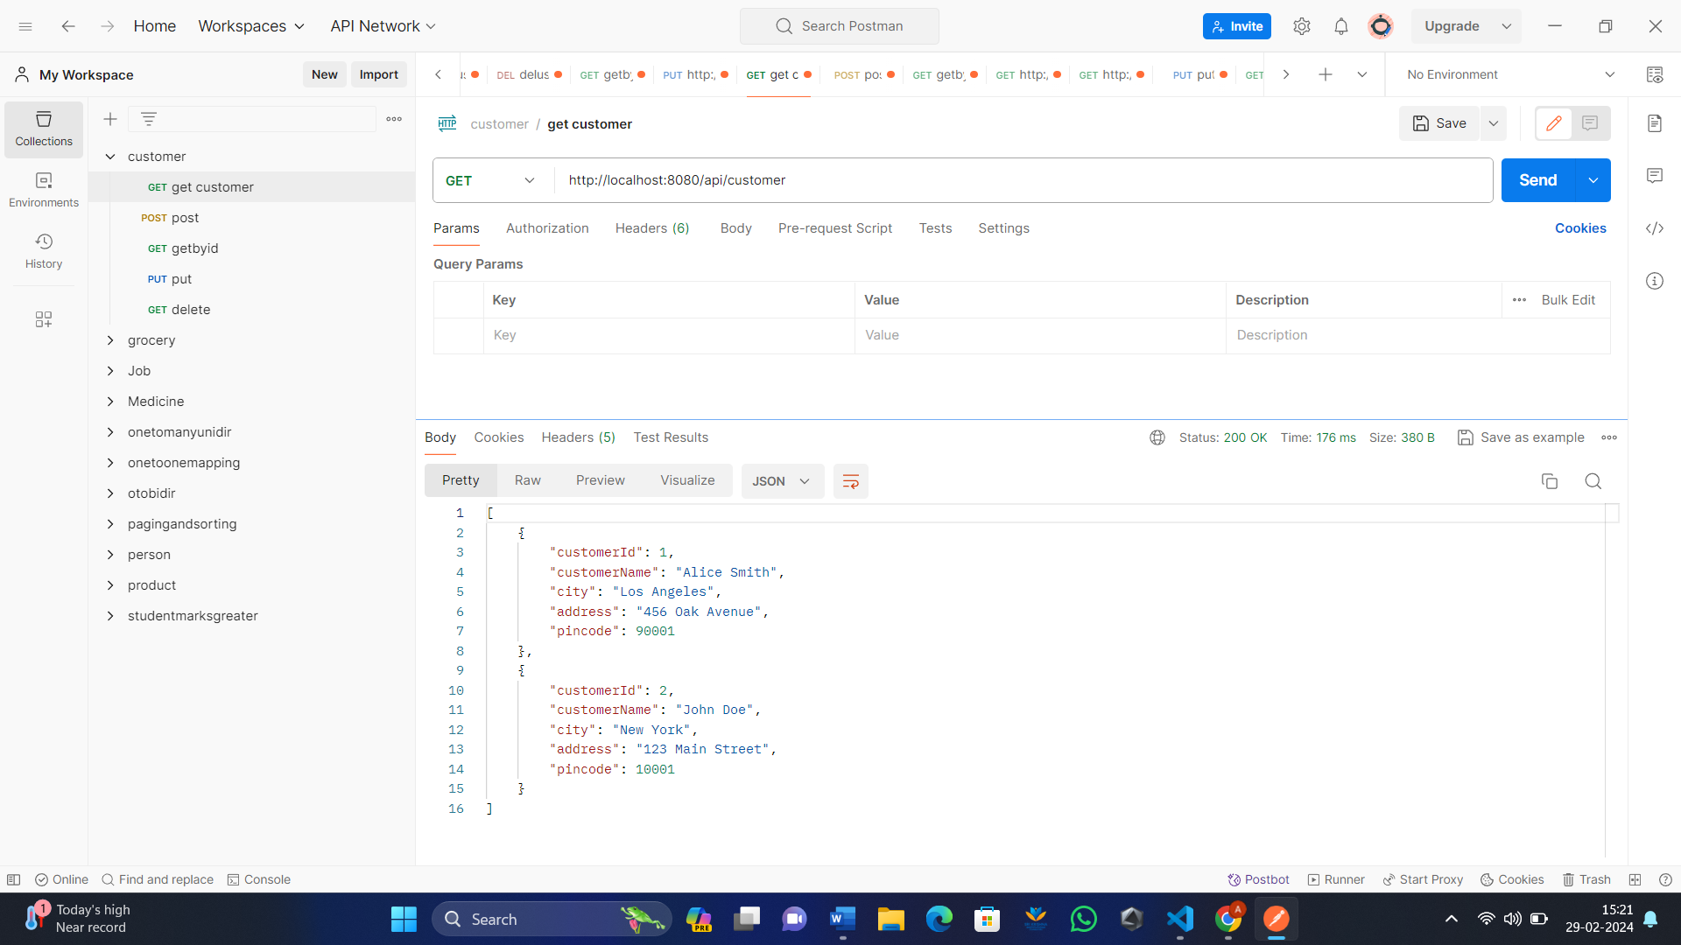

    @GetMapping("/api/customer/{customerId}")

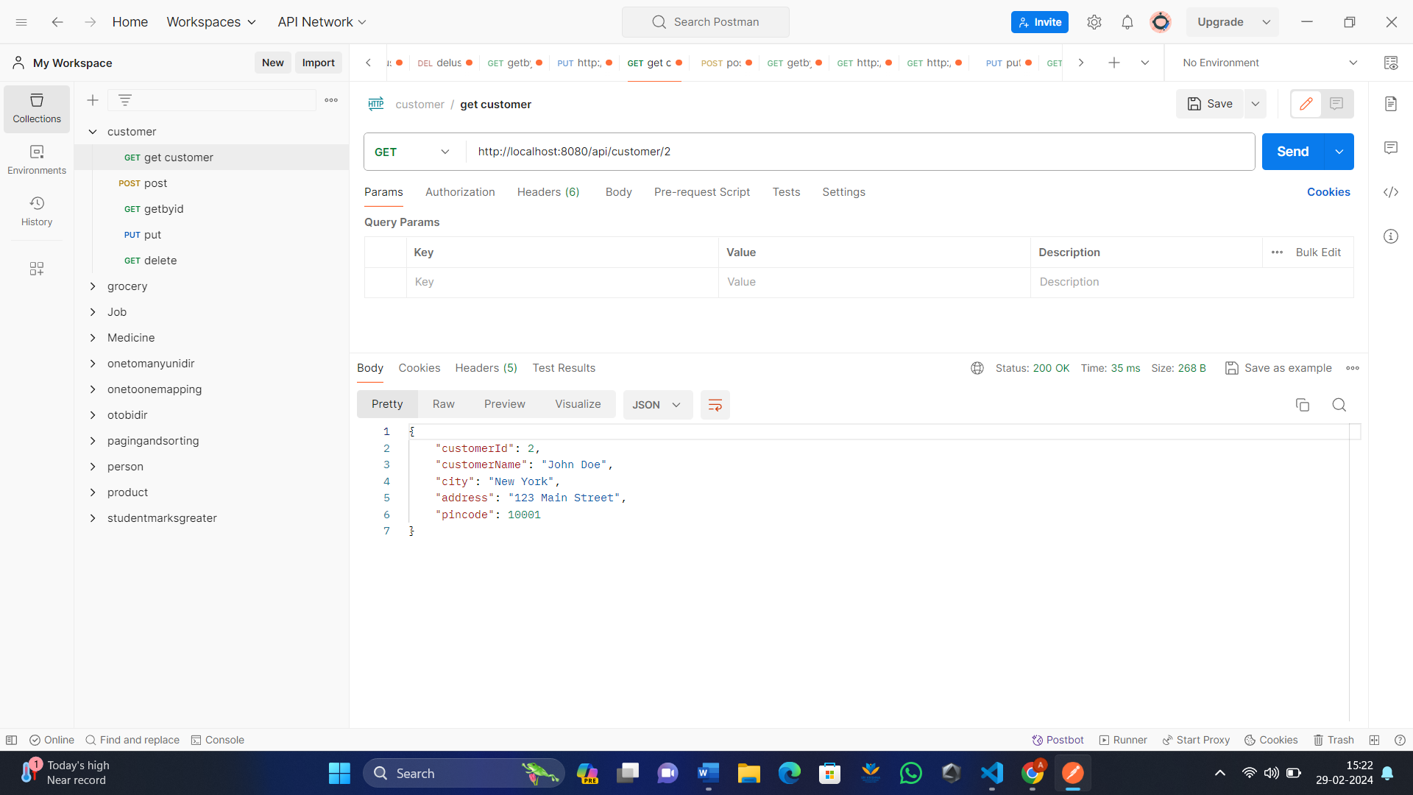

    @GetMapping("/api/customer/bycity/{city}")

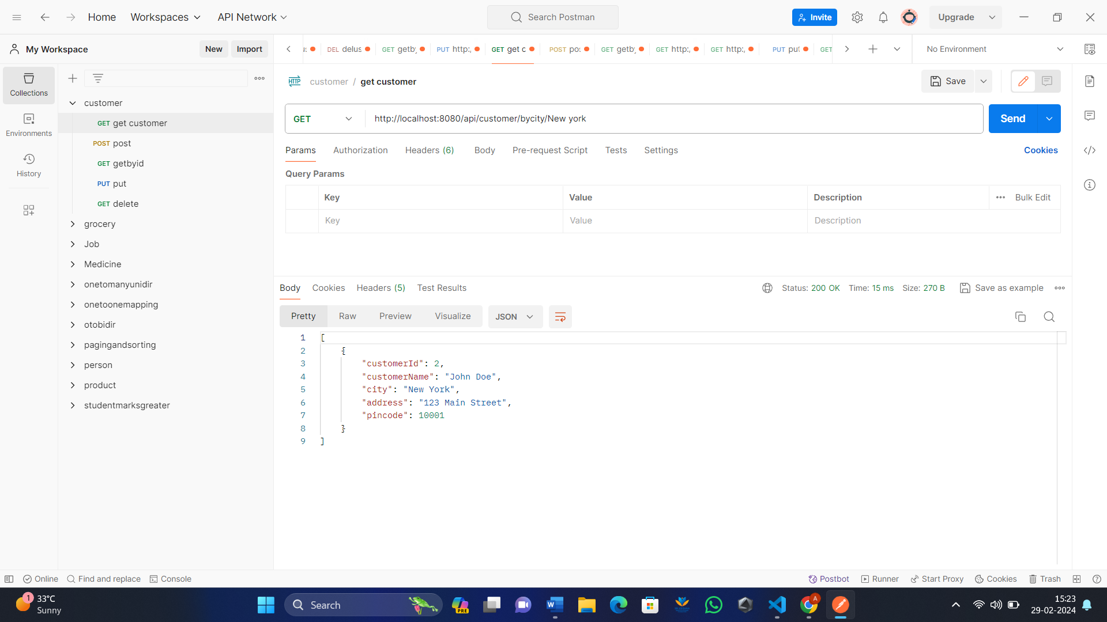

    @PutMapping("/api/customer/{customerId}/{pincode}")

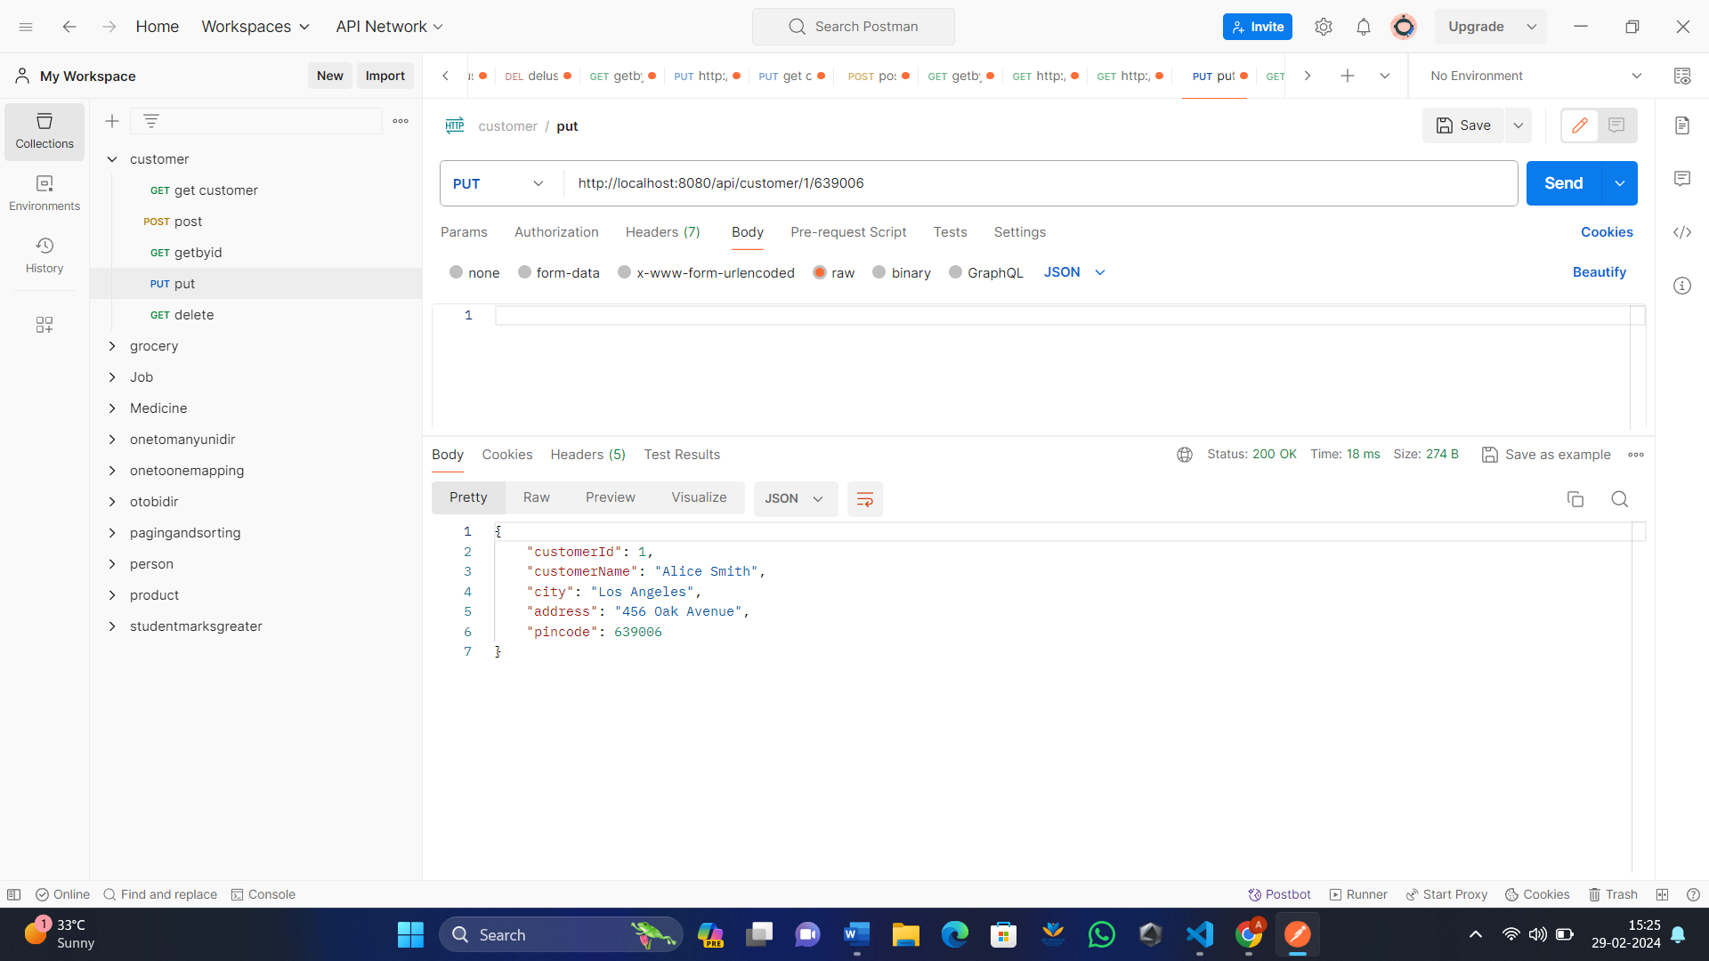

    @DeleteMapping("/api/customer/{customerId}")

